STOCK PRICE FORECASTING USING MACHINE LEARNING AND TIME SERIES ANALYSIS
Internship Project Report
Submitted By
KRITHIK S
ABSTRACT
Stock market prediction is one of the most challenging tasks in the field of data science due to the highly dynamic and volatile nature of financial markets. The objective of this project is to analyze historical stock market data and develop predictive models capable of forecasting future stock prices. Apple Inc. (AAPL) stock data was collected using the Yahoo Finance API and subjected to preprocessing, exploratory data analysis, feature engineering, and predictive modeling.

CHAPTER 1: INTRODUCTION
1.1 Background
The stock market plays a significant role in the global economy by facilitating investments and capital growth. Predicting stock prices accurately can assist investors in making informed decisions and minimizing financial risks.
Recent advancements in Machine Learning and Data Science have enabled researchers to build predictive models using historical stock data. These models analyse trends and patterns within historical data to forecast future market movements.
1.2 Problem Statement
The objective of this project is to predict stock price movements using historical stock market data and compare the effectiveness of different forecasting techniques.
1.3 Objectives
- Collect historical stock data.
- Perform data cleaning and preprocessing.
- Conduct exploratory data analysis.
- Engineer meaningful features.
- Develop predictive models.
- Compare model performances.
- Forecast future stock prices.

CHAPTER 2: DATA COLLECTION
2.1 Data Source
Historical stock data for Apple Inc. (AAPL) was collected using the Yahoo Finance API through the Python yfinance library.
2.2 Dataset Information
The dataset contains daily stock market information including:
Column | Description
Date | Trading date
Open | Opening stock price
High | Highest stock price of the day
Low | Lowest stock price of the day
Close | Closing stock price
Volume | Number of shares traded
2.3 Data Collection Method
Python Script:
import yfinance as yf
data = yf.download("AAPL",start="2015-01-01",end="2025-01-01")
data.to_csv("aapl.csv")

CHAPTER 3: DATA PREPROCESSING
3.1 Handling Missing Values
The dataset was inspected for missing values using Pandas.

Methods used:
- Linear Interpolation
- Forward Fill (FFill)
- Backward Fill (BFill)
These techniques ensured continuity in the time series data.
3.2 Data Type Conversion
The Date column was converted into DateTime format to enable time-series operations.
df['Date'] = pd.to_datetime(df['Date'])
3.3 Data Validation
The dataset was validated by:
- Checking data types
- Removing inconsistencies
- Handling missing values
- Verifying column integrity

CHAPTER 4: EXPLORATORY DATA ANALYSIS (EDA)
4.1 Statistical Summary
Descriptive statistics were generated using:
df.describe()
The summary provided:
- Mean
- Median
- Standard Deviation
- Minimum Value
- Maximum Value

4.2 Trend Analysis
The closing price trend was visualized over time.
Observation:
Apple stock demonstrated a long-term upward trend with periodic fluctuations caused by market conditions.
4.3 Volume Analysis
Trading volume was analyzed to understand market activity and investor participation.
4.4 Correlation Analysis
Relationships among stock attributes were examined to identify significant predictive variables.

CHAPTER 5: FEATURE ENGINEERING
Feature engineering was performed to create meaningful predictors from the raw dataset.
Features Created
Moving Average (MA20)
20-day moving average:
df['MA20'] = df['Close'].rolling(20).mean()
Moving Average (MA50)
50-day moving average:
df['MA50'] = df['Close'].rolling(50).mean()
Daily Return
df['Daily_Return'] = df['Close'].pct_change()
Lag Features
Previous closing prices were used as lag variables:
df['Lag1'] = df['Close'].shift(1)
df['Lag2'] = df['Close'].shift(2)
These engineered features helped improve predictive performance.

CHAPTER 6: MODEL DEVELOPMENT
6.1 Linear Regression
Linear Regression was used as a baseline machine learning model.
Advantages
- Simple
- Fast
- Interpretable
Performance
MAE: 0.61
MSE: 0.61
R² Score: 0.99

6.2 Random Forest Regressor
Random Forest is an ensemble learning technique that combines multiple decision trees.
Advantages
- Handles nonlinear relationships
- Robust to noise
Performance
MAE: 18.22
MSE: 810.04
R² Score: -0.09

6.3 ARIMA Model
ARIMA is a classical time-series forecasting technique.
Components
- AR (Auto Regression)
- I (Integrated)
- MA (Moving Average)
Performance
MAE: 18.85
MSE: 443.00
R² Score: -4.03
The ARIMA model struggled to capture recent upward trends in stock prices, resulting in lower predictive accuracy.

CHAPTER 7: MODEL EVALUATION
Evaluation Metrics
Mean Absolute Error (MAE)
Measures average prediction error.
Formula:
MAE = Σ|Actual − Predicted| / n
Mean Squared Error (MSE)
Measures squared prediction error.
Formula:
MSE = Σ(Actual − Predicted)² / n
R² Score
Measures proportion of variance explained by the model.
Formula:
R² = 1 − (Residual Sum of Squares / Total Sum of Squares)

CHAPTER 8: MODEL COMPARISON
Model | MAE | MSE | R² Score
Linear Regression | 0.61 | 0.61 | 0.99
Random Forest | 18.22 | 810.04 | -0.09
ARIMA | 18.85 | 443.00 | -4.03
Analysis
Linear Regression achieved the best performance among all implemented models.
Random Forest and ARIMA exhibited significantly higher errors and lower predictive capabilities for this dataset.

CHAPTER 9: RESULTS AND DISCUSSION
The results demonstrate that Linear Regression successfully modeled the relationship between stock attributes and closing prices.
Although Random Forest and ARIMA are powerful techniques, they did not perform well on the selected dataset and forecasting setup.
The study highlights the importance of selecting appropriate models and feature engineering strategies when dealing with financial time series data.
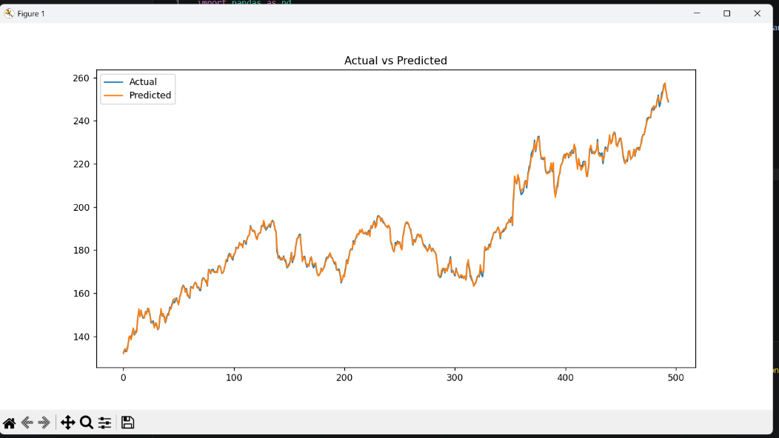

CHAPTER 10: CONCLUSION
This project successfully implemented a complete stock forecasting pipeline using Data Science and Machine Learning techniques.
The workflow included:
- Data Collection
- Data Cleaning
- Exploratory Data Analysis
- Feature Engineering
- Machine Learning Modeling
- Time Series Forecasting
- Model Evaluation
Among all models tested, Linear Regression achieved the best performance with an MAE of 0.61 and an R² score of 0.99.
The project demonstrates the practical application of machine learning techniques in financial forecasting and provides a foundation for future research in stock market prediction.

FUTURE SCOPE
Future enhancements can include:
- Long Short-Term Memory (LSTM) Networks
- XGBoost Models
- Real-Time Data Streaming
- News Sentiment Analysis
- Portfolio Optimization
- Deployment as a Web Application using Streamlit

REFERENCES
- Yahoo Finance API Documentation
- Python Pandas Documentation
- Scikit-Learn Documentation
- Statsmodels Documentation
- Machine Learning for Financial Forecasting Research Papers
- Time Series Analysis and Forecasting Literature

